Fatal error when using GITSCC SCC API plug-in in CodeWright
Fatal error when trying to setup Version Controle in CodeWright v.7.0c (see the following screen dumps)

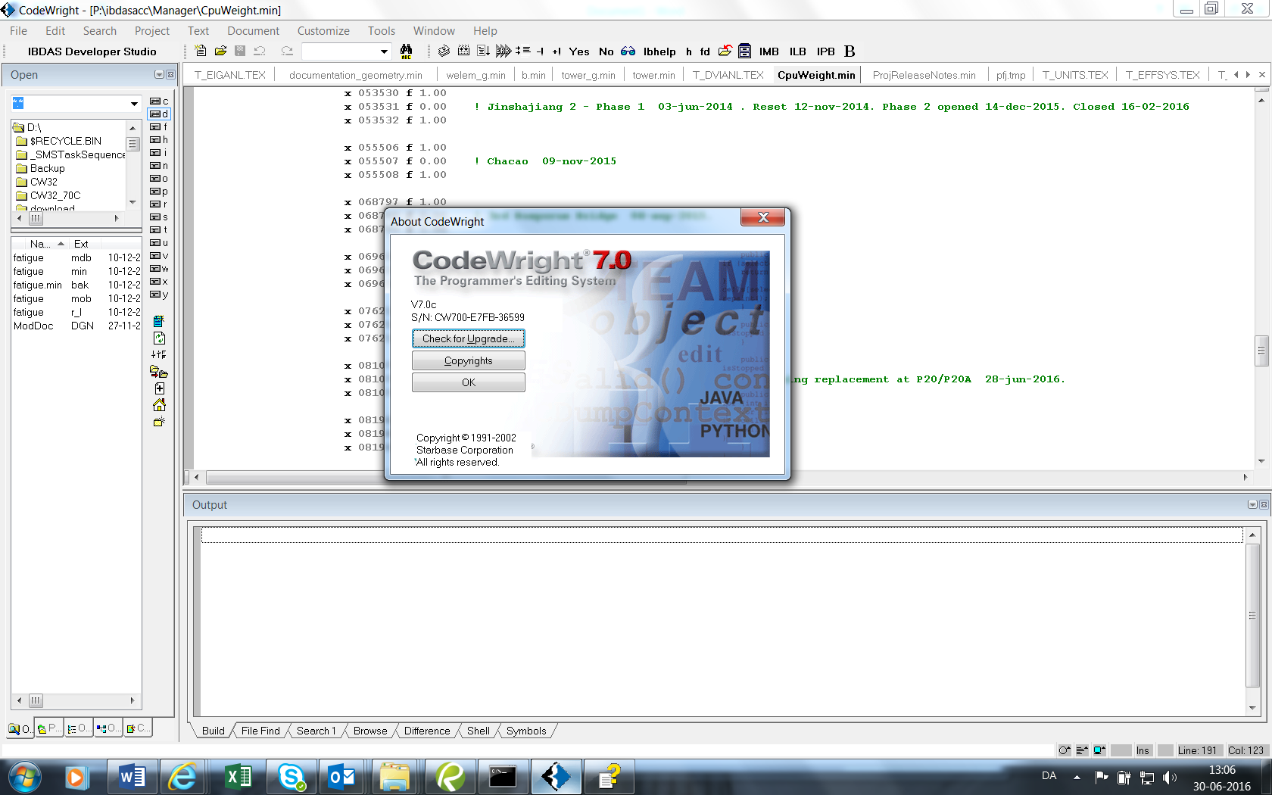
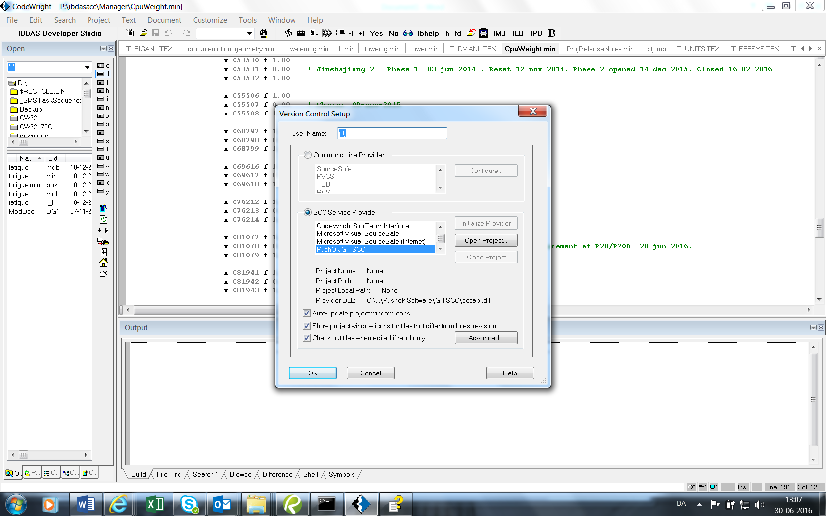

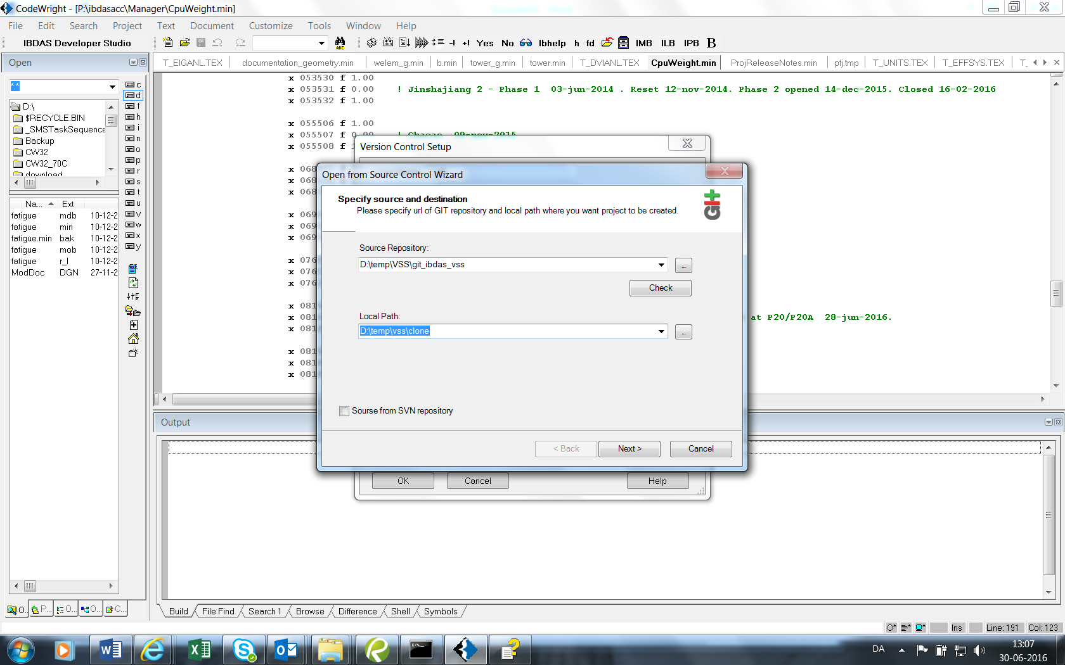

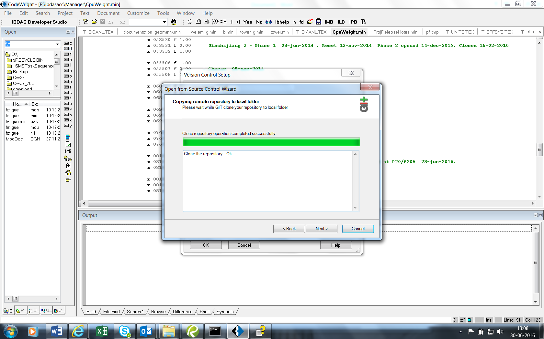

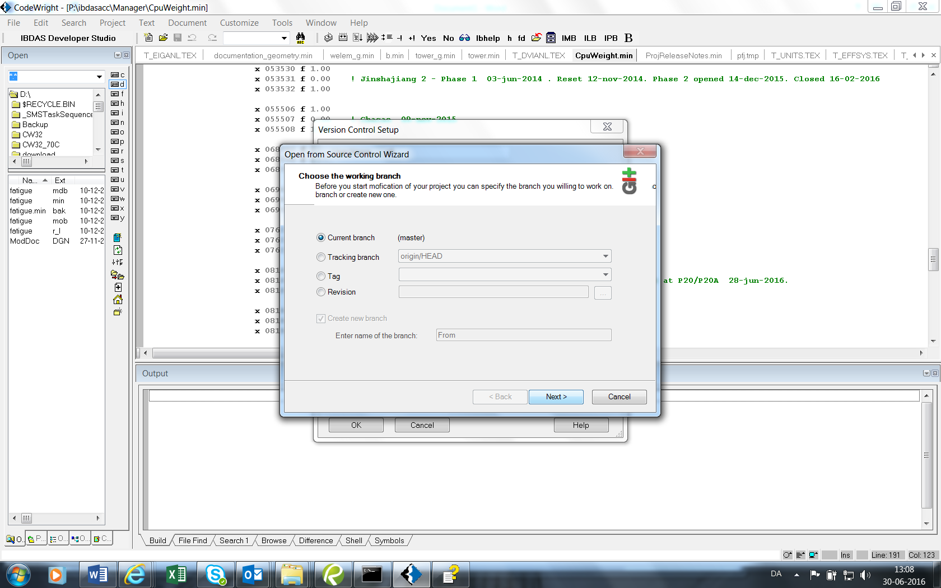

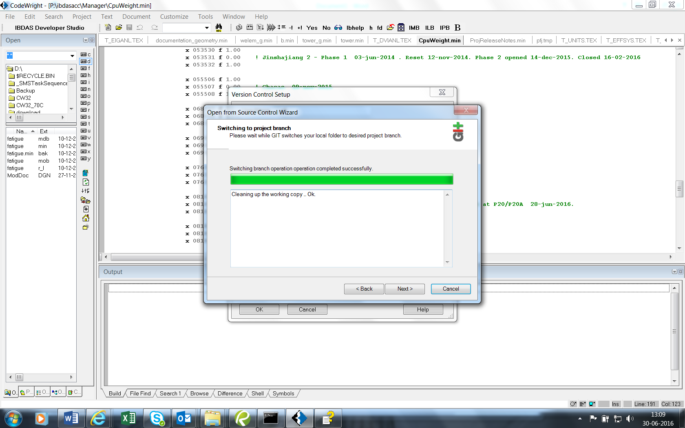

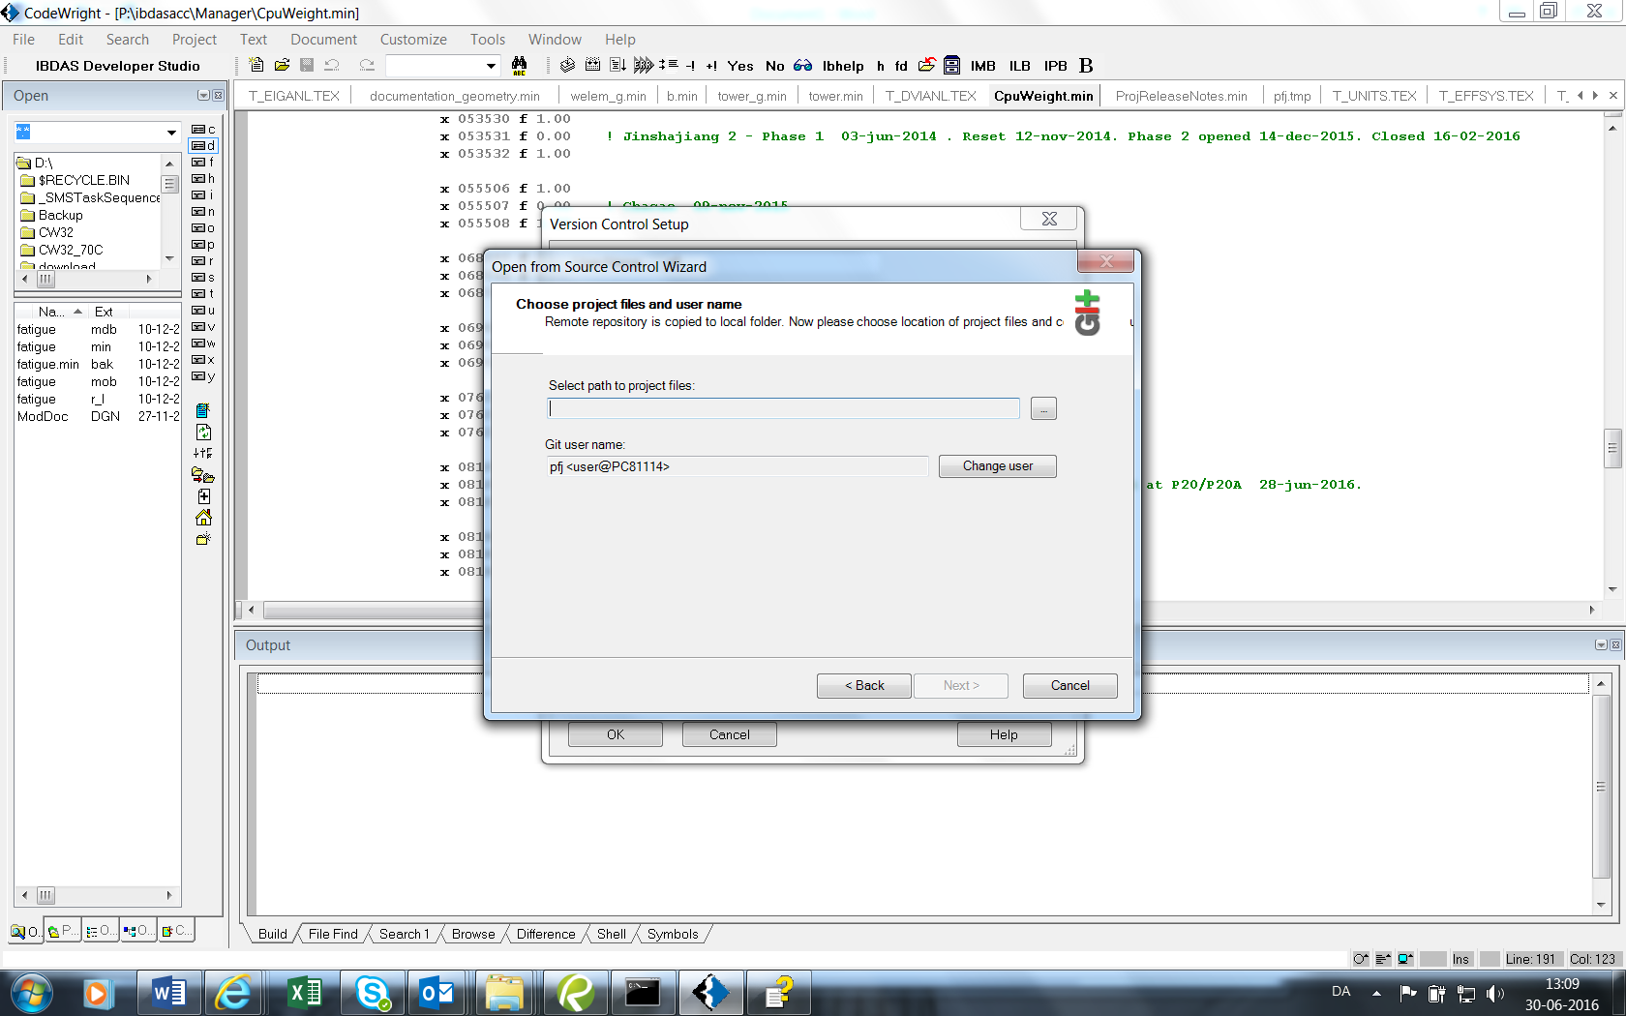

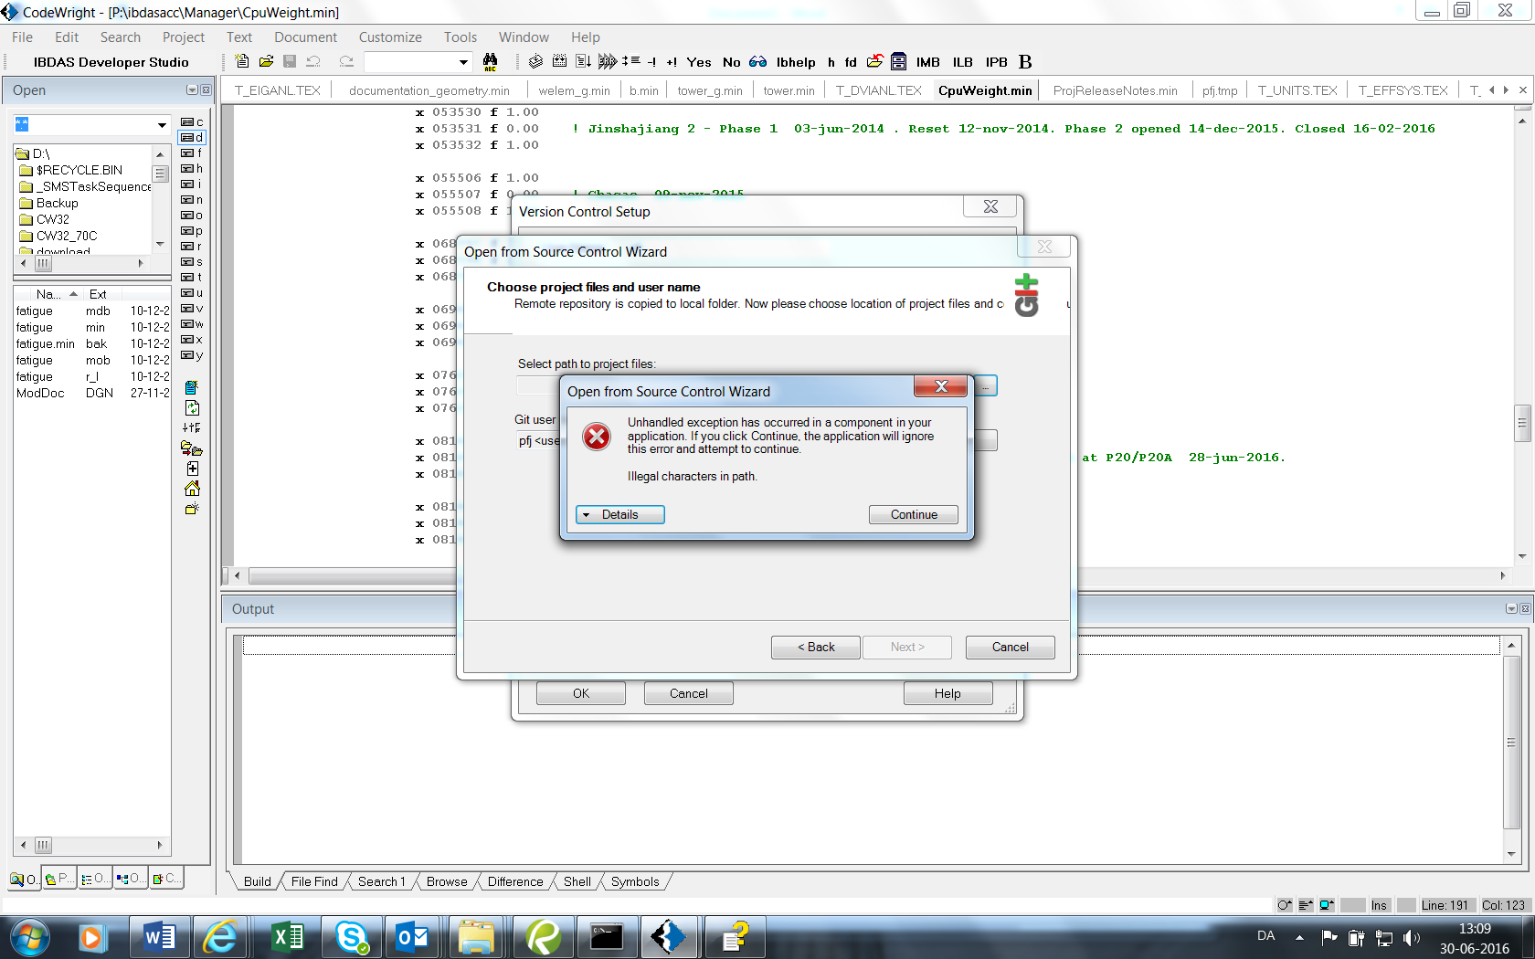
Details buttom:
See the end of this message for details on invoking
just-in-time (JIT) debugging instead of this dialog box.

************** Exception Text **************
System.ArgumentException: Illegal characters in path.
at System.IO.Path.CheckInvalidPathChars(String path)
at System.IO.Path.Combine(String path1, String path2)
at PushOk.GitSccLib.Forms.Wizard.OpenProject.Select.btnFiles_Click(Object sender, EventArgs e)
at System.Windows.Forms.Control.OnClick(EventArgs e)
at System.Windows.Forms.Button.OnClick(EventArgs e)
at System.Windows.Forms.Button.OnMouseUp(MouseEventArgs mevent)
at System.Windows.Forms.Control.WmMouseUp(Message& m, MouseButtons button, Int32 clicks)
at System.Windows.Forms.Control.WndProc(Message& m)
at System.Windows.Forms.ButtonBase.WndProc(Message& m)
at System.Windows.Forms.Button.WndProc(Message& m)
at System.Windows.Forms.Control.ControlNativeWindow.OnMessage(Message& m)
at System.Windows.Forms.Control.ControlNativeWindow.WndProc(Message& m)
at System.Windows.Forms.NativeWindow.Callback(IntPtr hWnd, Int32 msg, IntPtr wparam, IntPtr lparam)

************** Loaded Assemblies **************
mscorlib
Assembly Version: 2.0.0.0
Win32 Version: 2.0.50727.5485 (Win7SP1GDR.050727-5400)
CodeBase: file:///C:/Windows/Microsoft.NET/Framework/v2.0.50727/mscorlib.dll
----------------------------------------
sccapi
Assembly Version: 1.0.3825.22789
Win32 Version: 1, 0, 0, 3
CodeBase: file:///C:/Program%20Files%20(x86)/Pushok%20Software/GITSCC/sccapi.dll
----------------------------------------
msvcm90
Assembly Version: 9.0.30729.6161
Win32 Version: 9.00.30729.6161
CodeBase: file:///C:/Windows/WinSxS/x86_microsoft.vc90.crt_1fc8b3b9a1e18e3b_9.0.30729.6161_none_50934f2ebcb7eb57/msvcm90.dll
----------------------------------------
PushOk.GitSccLib
Assembly Version: 1.0.0.3
Win32 Version: 1.0.0.3
CodeBase: file:///C:/Windows/assembly/GAC_MSIL/PushOk.GitSccLib/1.0.0.3__9cceb4c916fc06e7/PushOk.GitSccLib.dll
----------------------------------------
System
Assembly Version: 2.0.0.0
Win32 Version: 2.0.50727.5485 (Win7SP1GDR.050727-5400)
CodeBase: file:///C:/Windows/assembly/GAC_MSIL/System/2.0.0.0__b77a5c561934e089/System.dll
----------------------------------------
System.Windows.Forms
Assembly Version: 2.0.0.0
Win32 Version: 2.0.50727.5491 (Win7SP1GDR.050727-5400)
CodeBase: file:///C:/Windows/assembly/GAC_MSIL/System.Windows.Forms/2.0.0.0__b77a5c561934e089/System.Windows.Forms.dll
----------------------------------------
System.Drawing
Assembly Version: 2.0.0.0
Win32 Version: 2.0.50727.5495 (Win7SP1GDR.050727-5400)
CodeBase: file:///C:/Windows/assembly/GAC_MSIL/System.Drawing/2.0.0.0__b03f5f7f11d50a3a/System.Drawing.dll
----------------------------------------
System.Configuration
Assembly Version: 2.0.0.0
Win32 Version: 2.0.50727.5483 (Win7SP1GDR.050727-5400)
CodeBase: file:///C:/Windows/assembly/GAC_MSIL/System.Configuration/2.0.0.0__b03f5f7f11d50a3a/System.Configuration.dll
----------------------------------------
System.Xml
Assembly Version: 2.0.0.0
Win32 Version: 2.0.50727.5494 (Win7SP1GDR.050727-5400)
CodeBase: file:///C:/Windows/assembly/GAC_MSIL/System.Xml/2.0.0.0__b77a5c561934e089/System.Xml.dll
----------------------------------------

************** JIT Debugging **************
To enable just-in-time (JIT) debugging, the .config file for this
application or computer (machine.config) must have the
jitDebugging value set in the system.windows.forms section.
The application must also be compiled with debugging
enabled.

For example:

<configuration>
<system.windows.forms jitDebugging="true" />
</configuration>

When JIT debugging is enabled, any unhandled exception
will be sent to the JIT debugger registered on the computer
rather than be handled by this dialog box.

